*To access this template for free, visit:* [*http://www.sageproducts.com/education/pdf/20786G.docx*](http://www.sageproducts.com/education/pdf/20786G.docx)

***[Hospital Name]***

***[This document should be customized to meet the needs of your facility, based on your patient preoperative skin preparation protocol.]***

**Preparing the Skin Before Surgery**

Preparing or “prepping” skin before surgery can reduce the risk of infection at the surgical site. To make the process easier, this facility has chosen disposable cloths moistened with a rinse-free, 2% Chlorhexidine Gluconate (CHG) antiseptic solution. The steps below outline the prepping process and should be carefully followed.

**Prep the skin at the following time(s): Prep the circled area(s) only:**

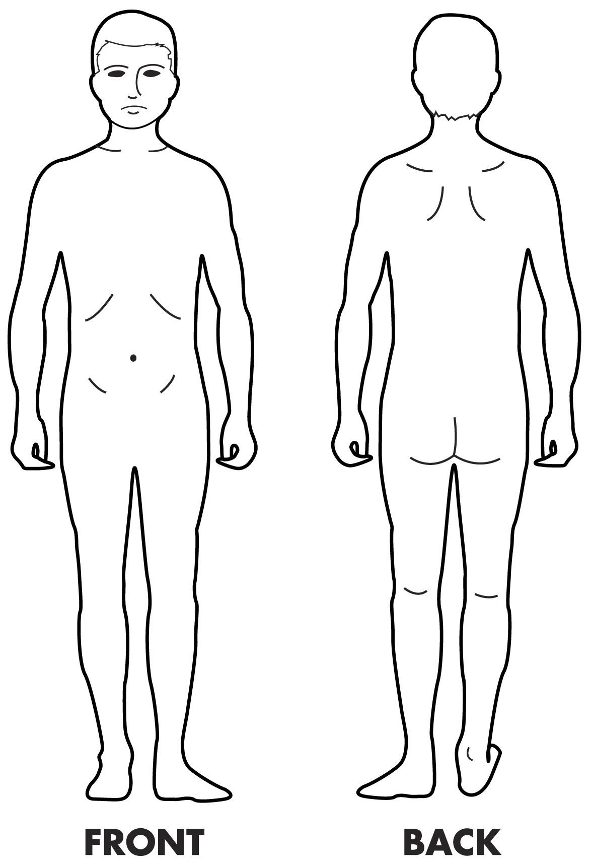

_______________________________

_______________________________

_______________________________

_______________________________

_______________________________

_______________________________

_______________________________

**Directions:**

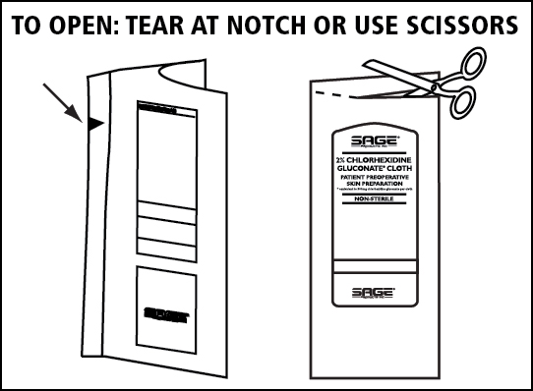Once prepping with the 2% CHG cloths begins, do not shower, bathe or apply lotions, moisturizers or makeup. Water and ingredients commonly found in personal care products can reduce the antiseptic effects of CHG. Since CHG works best when left on the skin, do not rinse it off. If showering or bathing is desired, the water should be warm not HOT. Shower or bathe at least **one hour before prepping** skin for the first time. When applying CHG, your skin should be completely dry and cool. When applied to sensitive skin, CHG may cause skin irritation such as a temporary itching sensation and/or redness. Showering or shaving immediately before applying CHG may enhance this effect. Shaving should be suspended at least 2 days prior to surgery on all areas of the body, including the face, legs, underarms, etc. If itching or redness persists, rinse affected areas and discontinue use.

* **To open the package(s):** Holding top of package in one hand, lift flap on backside of  
  package with other hand. Grasp flap at top and pull down to tear flap away and expose foam.   
  Hold outside of package to present foam and cloths to prep table, avoiding contact between   
  cloths and outside of package to reduce risk of cloth contamination.  
    
   ***[or, based on product configuration used:]***Using sterile scissors, cut off end seal of package. Transfer contents onto prep table,

avoiding contact between cloths and outside of package to reduce risk of cloth contamination.

* **Prepping the patient’s skin:** Prep the area(s) circled above. Avoid contact with eyes, ears and mouth.   
  ***[Add prepping instructions here, based on facility protocol or individual patient needs.]***
* Use all cloths in the package(s).
* Allow area to air dry for one minute. Do not rinse. It is normal for the skin to have a temporary  
  “tacky” feel for several minutes after the antiseptic solution is applied.
* Place the Prep Check™ sticker(s) from the package on the bottom of this sheet as indicated.

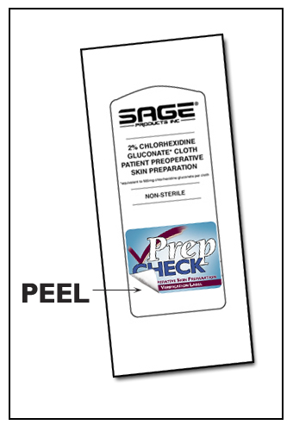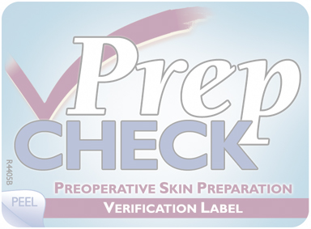

**PLACE**

**LABEL**

**HERE**

**PLACE**

**LABEL**

**HERE**

**Initials**________ **Date**________

**Initials**________ **Date**________

20786G